Czech-Austrian Winter and Summer School

Possibilities to safe electricity for households

Bloder Annette
Hanžlová Barbora
Pojer Doris

Co-operating Universities



Financial support by

Prague and Vienna, 2009
Index

1 Abstract 3
2 Introduction 3
2.1 Energy consumption 4
2.2 Energy consumption in households 4
3 Electricity consumption in households 5
3.1 Electricity consumption in Austria 6
3.2 Electricity consumption in the Czech Republic 9
3.3 Possible savings and advices for saving electricity at home 10
3.3.1 Living room 10
3.3.2 Kitchen 11
3.3.3 Lighting 13
3.3.4 Bath room 14
3.4 More possibilities to save electricity and costs 15
3.4.1 EU Energy label 15
3.4.2 Energy Star 16
3.4.3 Electricity Measurement equipment 16
3.4.4 Electricity / Utility Bill 16
3.5 The benefits for households of saving electricity 17
4 Conclusion 18
List of Figures 19
References 20

Abstract
The paper aims to expose the reasons why the consumption of electricity is increasing in Austria and in the Czech Republic. The coherency between increasing prosperity and increasing electricity consumption would be pointed out by explaining the rebound effect. (Rebound effect means that technological improvements sometimes result in increased consumption and environmental pressures)
The possibilities and benefits for the households for reducing the electricity consumption would be illustrated for Austria and the Czech Republic. Finally there would be quoted what each and every one of us can do to reduce the electricity consumption.

Questions we want to resolve
1. Why is the consumption of electricity increasing?
2. What are the benefits for households of changing their behaviour?
3. What can the individuals do?

Introduction

Energy means live. In its many different kinds, it is an important commodity in our all personal and economical existences. But the energy sources, the raw materials and the necessary infrastructure, are short and limited available commodities.

Energy means live and therefore for the mankind the responsibility but also the chance to use the available resources in the best possible and responsible way consistent with nature.

By selective energy savings in households the environment and the economy profit. But there are more motives for energy saving and increasing the energy efficiency:

- A country depends less from energy imports
- The use of primary energy in power station is reduced
- The environment is prevented by the fewer CO2 impact
- The country as business location and working place is protected. (Energie Graz 2008)

The greatest power plant is saving energy! If we would always deactivate the standby-modus of all our appliances all around Austria, we would save energy in an extent of a Donau power station in Austria. (Sattler Energie Consulting, 2009) Facts like this motivate us to engage in the topic of electricity savings in households.

Energy consumption
Energy production is a global issue. Hand in hand with economic growth, ongoing industrialization and population growth, the demand for energy has an increasing tendency already over decades. According to the International Energy Agency the world-wide energy consumption will on average continue to increase by 2% per year.

In years 1990 – 2005 the consumption of energy grew in the EU by 0,6% per year on average. This growth rate is lower then the one of gross domestic product, so the energy efficiency is in general increasing. If we focus on particular sectors, the energy efficiency has become better mainly in industry and services sectors, is only slightly improving in transport sector and has worsened in households (EEA 2008).

Energy consumption in households
Households in the EU are responsible for almost 27% of final energy consumption. This is approximately the same amount as used for industry (Eurostat 2005 in EEA 2005) or in some countries it even higher.
Therefore the potential in this sector to improve the energy efficiency and to reduce the consumption is high. Over the whole period 1990-2005 the energy consumption in households grew by 11.6% and the electricity consumption by 31.1% (EEA 2005).

The largest part of spent energy (67%) is used for space heating, followed by water heating (14%) and electronic devices plus lighting (12%) (Enerdata 2004 in EEA 2005).
Despite the efficiency efforts this numbers are still increasing. Reasons for this evidence are as follows.

The key determinants of energy demand in the households are: economic development, level of urbanization, living standards, prices of fuels and appliances, income of households, availability of fuels and appliances, particular requirements related to each and preferences.
Generally, when people get richer they require higher comfort. Households in developed countries consume on average nine times more energy then people in developing countries (Dzioubinski 1999).

The contemporary social trend contributes to the fact that the number and size of households is increasing and therefore is the final amount of energy used for heating increasing as well (Rijkens-Klomp and Lieshout, 2004). This happens even though the fact that the general quality of new housing has improved, mainly as a result of better insulation and more energy-efficient heating (Flats and houses built in 2002 consume 24% less energy per square meter than those built ten years ago (Enerdata 2004 in EEA 2005)). On the other hand comfort levels of standard living have risen as well. People changed their behaviour patterns.

Further, households are better provided with electronic and communication devices. The amount of energy powered appliances has increased several times in recent decades. Although these have become more energy-efficient, the increase in their number has outweighed efficiency gains. Improvements in the efficiency of many powered goods have been offset by their growth in number. This is called the rebound effect.

Electricity consumption in households
Total electricity consumption in the residential sector for the EU-25 has grown by 10.8% in the period 1999-2004, from 690 TWh in year 1999 to 765 TWh in year 2004 and by 1.8% in the period 2003-2004. Electricity use grows at almost the same rate as the economy (GDP).

Increasing electricity demand is due to many different factors, including:
- More penetration of “traditional” appliances (e.g. dishwashers, tumble driers, air conditioners, personal computers, which are all still far away from saturation levels); introduction of new appliances and devices, mainly consumer electronics and information and communication technology (ICT) equipment (Set Top boxes, DVD players, broadband equipment, cordless telephones, etc.) many with standby losses.
- Increased use of “traditional” equipment: more hours of TV watching, more hours of use of personal computer (driven by some tele-working and increased use of internet), more washing and use of hot water.
- Increased number of double or triple appliances, mainly TVs and refrigerators and freezers.
- More single family houses, each with some basic appliances, and larger houses and apartments. This results in more lighting, more heating and cooling, and last but not least, older population demanding higher indoor temperatures and all-day heating in winter and cooling in summer, and spending more time at home.
(European Commission, 2007)

Another reason fort he increasing electricity consumption is the rebound effect. In general, the term “rebound effect” refers to the amount of an energy saving caused by an efficiency investment that is taken back by consumers in the form of higher consumption (Herring 2008). It is expressed as a percentage of the projected and actual reductions in energy savings. The amount of the rebound effect shows how the calculated potential savings differ from the effective savings. A rebound effect of 100 % means, that no saving could be achieved. A rebound effect of 0 % means, that the calculated potential savings could be achieved totally. (Forum Wissenschaft und Umwelt, 2008)

The rebound effect consists of several partial effects:

Direct effects are those when the consumer chooses to use more of the resource instead of realizing the energy cost savings.
Indirect effects happen when the consumer uses the spent money by buying other goods which use the same resource.
Dynamic or market effects occur when after the decrease of demand for a resource the lower resource prices economically enable new uses of this resource (Gottron 2006).

Due to indirect effects the economy-wide decrease in energy consumption is smaller. Direct rebound effects are not so heavy when the energy makes only a small part of total costs and has little influence on operating decisions (Sorrell 2007).

For example, for large electronic devices (washing machines, refrigerators etc.) has the average energy consumption according to EEA Report decreased by 21 % during the nineties, but total energy consumption fell only by 2 %. The main reason was in the increased amount of home electronic appliances (EEA 2005).

The extent of rebound differs upon diverse circumstances. In some cases (for example new energy efficient technologies for energy intensive industries) the rebound effect may be 50% and so can lead to consequences such as increasing energy consumption in the long-term. For personal transport and household heating/cooling the rebound effect is about 30% and less, especially for transport. It is estimated for the future that this direct rebound effects may fell down as the demand saturates. On the other hand the economy-wide rebound effect by electronic devices and lighting is usually smaller (about 5 - 15%). Unfortunately under no circumstances it is likely to be zero (Sorrell 2007).

There is a need to take the rebound effect into account when planning energy efficiency policies. Where rebound effects are expected to be large, there may be a greater need for ensuring that the energy prices increases or the cost of energy services remains relatively constant while energy efficiency improves (Sorrell 2007). Beside the policy, there are other options how to reduce the environmental impact of households: more strict building standards, eco-labelling of electronic devices and others, changing behaviour patterns, water pricing etc.

Electricity consumption in Austria

In Austria the total electricity consumption is constantly rising. From 1970 till 2007 the consumption almost has been tripled as it’s shown in the figure bellow.
Fig. 1: Electricity consumption 1970-2007 (own figure, data Statistik Austria, 2007)

Also the electricity consumption of households was rising till 2006, but since then it is decreasing. In 1970 the households were responsible for 17 %, in 1990 for 27 % and in 2007 for about 25 % of the total consumption.
Fig. 2: Electricity Consumption in Austrian households (own figure, data Statistik Austria, 2007)

The following figure shows, which sectors are responsible for the electricity consumption. The data is from 2006. In Austria the industry is consuming 43 % of the total electricity. The households spend 26 % of the electricity.
Fig. 3: Electricity consumption (own figure, data Statistik Austria, 2007)

In Austria 20 % of the electricity in households is used for heating, 17 % for water heating and 17 % for large domestic appliances. How electricity can be saved in this fields is expailnd chapter 3.3

Fig. 4: Breakdown of electricity consumption (Statistik Austria, 2008)

Electricity consumption in the Czech Republic
In the year 2007 the amount of spent energy and fuels together made up 1 127 540 tera joules, whereof electricity did 201 330 tera joules (55 925 GWh) (Czech statistical office,http://www.czso.cz/csu/2009edicniplan.nsf/p/8106-09).

Bellow is to seen a chart displaying for what amount of energy consumption are particular sectors in CZ responsible.

Fig. 5: Energy consumption in CZ (own figure, data Czech statistical office, http://www.czso.cz/csu/2009edicniplan.nsf/p/8106-09)

In the next chart is to seen for what amount of electricity consumption are particular sectors in CZ responsible.

Fig. 6: Electricity consumption in CZ (own figure, data Czech statistical office, http://www.czso.cz/csu/2009edicniplan.nsf/p/8106-09)

Fig. 7: Electricity consumption per capita 1981-2003 CZ (own figure, data Enegreticky regulacni urad, http://www.eru.cz/user_data/files/statistika_elektro/rocni_zprava/2004/elektrina/2.htm)

The estimated growth rate of energy consumption for next years in CZ is 1%. This is lower then is expected for the whole EU, because the energy consumption in CZ should by partly out weighted by improvements in energy efficiency (which is nowadays much worse then is the EU-average).

Possible savings and advices for saving electricity at home
This part offers a lot of advices about how to save electricity at home by using technology and user behaviour, helping save money and the environment.
In the EU Action Plan 2006 is to the issue household energy savings said following:

„For the household and the service sectors, important actions are the development of minimum energy performance standards. These standards will be made for 14 priority groups of products (e.g. televisions, computers and stand-by modes) in the form of Directives, which are planned to be adopted by 2008. This follows the Eco Design directive (2005/32/EC). Furthermore, for buildings, the building performance requirements will be expanded in a revision of the Energy Performance of Buildings Directive (2002/91/EC) and financing of energy efficiency investments (e.g. by Energy Service Companies) will be stimulated.“
Among others the crucial role of education and raising energy efficiency awareness is pointed out.

Living room
The amount of entertainment electronics and personal computer is constantly rising. From LCD-televisions to DVD-Players and –recorders, play-stations to personal computers and notebooks the equipment is getting more and more comprehensive.

For this electronic equipment a lot of possibilities to save electricity are available:

- Standby-savings
To avoid standby-losses use a multiple socket outlet with an on-and-off-function so that the all connected appliances are automatically disconnected.

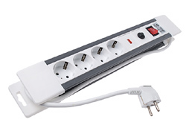
Fig. 8: multiple socket

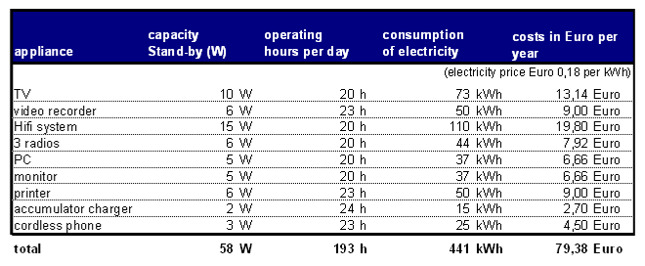
Fig. 9: Costs for stand-by (Energie Graz, 2008)

- For the purchase of appliances the energy indexes should be considered
- The bigger the screen the bigger the consumption
- Laptop needs less energy than PC-Station (screen, processor/computer, etc.)
- Screen savers are power-hungry
- Activate the energy-saving-function on your PC
- Modem and router for the internet and printer may not be activated all the time (Energie Graz 2008)

Kitchen
The easiest way to save energy in the use of household appliances is to replace old inefficient equipment. With new technology in washing machines, refrigerators, dishwashers, etc. 30 % energy savings and more can be quickly realised.
Household appliances are marked with „energy labels“ to show the energy efficiency (details see in chapter „Energy label“). But saving energy in the use of household appliances is not limited to the purchase of new devices. Energy can also be saved by using existing equipment with simple behavioral changes and optimizing of the utilization. These include examples of the following rules of conduct:

- Cooking stove
  - Modern cooking stoves are much more energy efficient than older appliances.
  - The floors of the cooking pots should be flat and the pot size should fit to the disk diameter.
  - Suitable and well-fitting lids can save 1/3 power.
  - Small quantities up to 400 g should be heated in the microwave.
  - Use of small appliances:
    - Egg cookers and kettles are more efficient than the stove. To boil water the kettle is more efficient.
  - Dishes with cooking times from 40 minutes in a pressure-cooker saves preparation time and up to 40 % of power.
  - Special cookware made of steel or copper saves up to EUR 9,- per year.

- Oven
  - The oven should only be used for larger amounts of food or for the simultaneous preparation of several dishes.
  - Opening the door should be avoided. There are always about 20 % of the heat lost.

- Microwave
  - The food should be uniformly flat distributed on the dish and you should stir in between.
  - special microwave dishes should be used

- Dish washer
  - The dish washer should only be activated when completely filled
  - Eco mode or short cleaning cycle should be used when the dishes are lightly dirty

- Refrigerator and freezer
  - The storage temperature in the frigerator should be between minus 5 and 7 degrees and in the freezer minus 18 degrees. Every further degree needs approx. 6 % more electricity.
  - Refrigerator and freezer should not be placed next to heating devices or the stove, and should be defended from solar radiation.
  - The appliance door should be opend shortely, so that few coldness gets out.
  - The appliance door should be completely sealed by the rubber seal.
  - The food should be put in only when it cooled down to room temperature.
  - The appliances should be defrosted regularely, because the ice cap affects as an insulating material.
  - The electricity consumption of one big refrigerator is lower than that one of two small appliances.
  - Refrigerators without freezing box need 20 % less energy.
  - The best place for seperate freezing appliances are unheated rooms.

Furthermore consider the energy consumption of new appliances in comparison to old appliances:

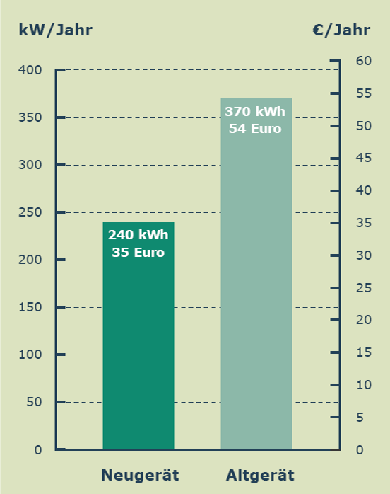
Fig. 10: Refrigerator and freezer - comparison of new and old equipment (Energie Graz, 2008)

Lighting
In most households, about 10-15% of the electricity bill is for lighting so energy saving light bulbs can cut the costs considerably. Traditional bulbs waste a lot of energy by turning it into heat but energy saving bulbs work in the same way as fluorescent lights, the tubes coating glows brightly as an electric current passed through gas in the tube. They may be more expensive to buy than traditional bulbs, but they are worth the investment as last over 10 times longer and use up to 4 times less energy. Where you would use a 100w ordinary bulb, you would only need a 20-25w energy saving bulb.
Benchmarking by same lightness:
traditional bulb | energy saving bulb
25 W | 5- 7 W
40 W | 7 - 9 W
60 W | 11 - 16 W
75 W | 15 - 20 W
100 W | 20 - 23 W
(OÖ Energiesparverband, 2008)

Other tips to save electricity:
- Get into the habit of turning lights off when you leave a room.
- Use only one bulb for light fittings with more than one light bulb, or replace additional bulbs with a lower wattage version.
- Use energy-saving light bulbs
- Use tungsten halogen bulbs for spotlights—they last longer and are up to 50 more efficient.
- Fit external lights with a motion sensor.
- Use high frequency fittings for fluorescent tubes because they cut flicker and are even more efficient than energy-saving light bulbs. They are suitable for kitchens, halls, workshops and garages. (Direct Energy Marketing, 2009)

Bath room
- Laundry
  - Wash full loads of laundry. You will use your machine less often, saving time, and it is more energy-efficient.
  - Wash at a lower temperature or the economy setting to save even more.
  - If you need to tumble dry, try a lower temperature setting.
  - Use your dryer for consecutive loads, because the built-up heat between loads will use less energy.

- Hot water
  - Check your hot water temperature. It does not need to be any higher than 60 °C for washing purposes.
  - Plug the basin or bath when you run any hot water.
  - Use a timer to make sure the heating and hot water are only on when needed.
  - Insulate your hot water pipes to prevent heat loss, and your water will stay hotter for longer.
  - Take showers—a bath consumes 5 times more hot water. Buy a low-flow showerhead for more efficiency and it will pay for itself in no time.
  - Avoid washing dishes under hot running water, and do not pre-rinse before using the dishwasher.
  - Make sure hot water taps are always turned off properly.
(Direct Energy Marketing, 2009)

More possibilities to save electricity and costs
This chapter lines out some more possibilities to save electricity and costs like considering labels, use of appliances for controlling electricity consumption and possibilities on the electricity supply market by looking at the electricity bill.

EU Energy label
As an additional instrument to gain the customers' attention and to help them with the decision for an energy efficient appliance, an energy efficiency label is used. The EU energy label rates products from A, (the most efficient) to G (the least efficient). For refrigeration the EU energy label goes up to A++. By law, the label must be shown on all refrigeration appliances, electric tumble dryers, washing machines, washer dryers, dishwashers, electric ovens, air conditioners, lamps and light bulb packaging. (Energy Saving Trust, UK)

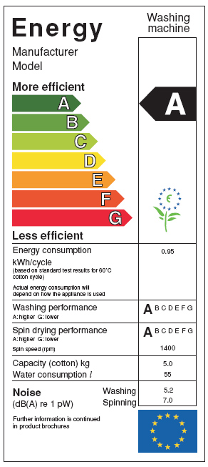
Fig. 11: EU energy label washing machine

Energy Star
The Energy Star Label is a symbol for a minimum standard for energy-efficient office equipment. Energy Star products cover a wide range of products, from simple scanners to complete desktop home computer systems. Manufacturers themselves can choose where to put the logo, so this may differ from product to product and manufacturer to manufacturer.(http://www.eu-energystar.org/de/index.html) 
Fig. 12: Energy Star label

Electricity Measurement equipment
Control of consumption means control of costs. Those who are informed about their energy consumption by controlling it, can influence the consumption easier and find causes and solutions for a high consumption. To see the counter / meter reading regularly can be helpful therefore. Or use an electricity measurement equipment to analyse the current consumption of your appliances.
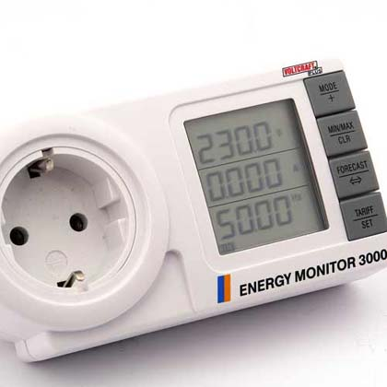
Fig. 13: Energy monitor

Energy monitors are available for Euro 12,- in electric shops.

Electricity / Utility Bill
Last but not least this thesis considers the electricity bill. There are four important parts which get explained here:

- Price for energy
The price for energy is competed in the market. It covers almost one third of the total electricity bill. To save money, it is sometimes better to switch the operator.

- Electricity network rate
The electricity network rate is the fee, which the operator gets. The height of this rate determined in Austria by E-Control and in the Czech Republic by the Energy Regulation Authority. The customer can not change the electricity network. The electricity network using costs are for building and maintenance the infrastructure.

- Legal dues and taxes
The energy due (also electricity due called) is in Austria 1,50 Cent per KWh. Since the year 2008 is this tax paid in CZ as well. It is not the responsibility of an individual consumer but of the supplier. The tax is 28,30 CZK/MWh high.

- All round price
The summation of the three parts is liable to purchase tax. (20 % in Austria and 19 % in the Czech Republic)

3.5 The benefits for households of saving electricity
One of the reasons why to safe electricity is the fact that the current amount of spent electricity is not fully justifiable. We have already technologies that enable us to live at the same standard of living as we do now but reduce our electricity consumption radically.

Possibly motivations for households for saving energy can be in principle two: respect to environment and money savings. Respect to environment can be strengthen by education, by values set in society, examples of good practises.

Money savings are one of the main tools used by politicians. But we have to realize that when people save money by saving energy, they always allocate their money in any other way. The crucial issue is in what way and if this way is even more environmentally harmful or not. By using electricity efficient appliances there is maybe a big potential of saving electricity, but not energy in general – almost all goods or services consumed instead (air trip, new car...) need energy.

Two small examples how many money can be saved by reducing the electricity consumption:
- A household with two persons needs approximately 2900 kWh per year. If the price for electricity is calculated with 22 Cent per kWh the annual costs are 638 Euro. By reducing the electricity consumption only by 10 %, there can be saved 63,80 Euro per year!
- A household with five people needs approximately 5300 kWh per year. If the price for electricity is calculated with 22 Cent per kWh the annual costs are 1166 Euro. By reducing the electricity consumption only by 10 %, there can be saved 116,60 Euro per year! (Nergico, 2009)

There is a need to practice a policy, which people forces by small steps to behave more energy efficient. One of the tools is definetely the price.
An undeniable benefit is the lower dependence on energy resources or on energy rich, but unstable countries. This includes also the lower dependence on fossil fuels at all.

4 Conclusion
In this paper we tried to answer three questions.
There are couple of reasons why the electricity consumption in households is increasing. The society is getting wealthier and so can and wants to afford more. Simultaneously the size of world population is still growing and changing its behavioural and consumer patterns. People are getting more individual, they don’t live in populous households anymore.

What the individuals can do we tried to describe and sum up in the chapter 3.3. Possibilities are wide; individuals can safe electricity by almost all daily performed activities. Important is to accent the necessary conditions – people have to know about it and be motivated to do it. The role of environmental education is anyhow crucial, concerning the motivation.

The benefits for households of changing their behaviour are obvious. By increasing the electricity consumption there can be saved money and the environment is preserved. For example like described in chapter 3.3.1 there can be saved a lot of money by switching of the stand-by mode.

List of Figures

Fig. 1: Electricity consumption 1970-2007 (own figure, data Statistik Austria, 2007) 7
Fig. 2: Electricity Consumption in Austrian households (own figure, data Statistik Austria, 2007) 7
Fig. 3: Electricity consumption (own figure, data Statistik Austria, 2007) 8
Fig. 4: Breakdown of electricity consumption (Statistik Austria, 2008) 8
Fig. 5: Energy consumption in CZ (own figure, data Czech statistical office, http://www.czso.cz/csu/2009edicniplan.nsf/p/8106-09) 9
Fig. 6: Electricity consumption in CZ (own figure, data Czech statistical office, http://www.czso.cz/csu/2009edicniplan.nsf/p/8106-09) 9
Fig. 7: Electricity consumption per capita 1981-2003 CZ (own figure, data Enegreticky regulacni urad, http://www.eru.cz/user_data/files/statistika_elektro/rocni_zprava/2004/elektrina/2.htm) 10
Fig. 8: multiple socket 11
Fig. 9: Costs for stand-by (Energie Graz, 2008) 11
Fig. 10: Refrigerator and freezer - comparison of new and old equipment (Energie Graz, 2008) 13
Fig. 11: EU energy label washing machine 15
Fig. 12: Energy Star label 16
Fig. 13: Energy monitor 16

References

- Czech statistical office: Rozdeleni konecne spotreby podle odvetvi (Division of end consumption by sector). Viewed on 25/05/2009. http://www.czso.cz/csu/2009edicniplan.nsf/p/8106-09
- Direct Energy Marketing: Tips to Help You Reduce Your Electricity Bill, Texas 2009
- Dzioubinski, Oleg; Chipman, Ralph: Trends in Consumption and Production: Household Energy Consumption, United Nations 1999
- EEA: Household consumption and the environment. Copenhagen 2005
- EEA: EN21 Final Energy Consumption Intensity. Viewed on 20/05/2009. http://www.eru.cz/user_data/files/statistika_elektro/rocni_zprava/2004/elektrina/2.htm
- EEA: Energy and environment report 2008. Copenhagen 2008.
- Energeticky regulacni urad (Energy regulation office): Spotreba elektriny v domacnostech na obyvatele CR (electricity consumption of households per capita). Viewed on 20/05/2009. http://www.eru.cz/user_data/files/statistika_elektro/rocni_zprava/2004/elektrina/2.htm
- Energie Graz: Energiespartipps.http://www.e-control.at/de/konsumenten/energie-sparen/energiespartipps/entertainment-pc
- Energie Graz: Energiespartipps für Zuhause. Graz 2008
- Energy Saving Trust, UK: http://www.energysavingtrust.org.uk/Energy-saving-products/About-Energy-Saving-Recommended-products/Other-energy-labels
- European Commission: Electricity Consumption and Efficiency Trends in the Enlarged European Union. Italy, 2007
- Forum Wissenschaft und Umwelt interdisziplinät: Energiezukunft. Wien 2008
- Gottron, Frank. Energy Efficiency and the Rebound Effect: Does Increasing Efficiency Decrease Demand? National Council for Science and the Environment, Washington, DC 2006.
- Herring, Horace. Rebound effect. The encyclopedia of earth. 18/12/2008, viewed on 25/04/2009, http://www.eoearth.org/article/Rebound_effect
- Institut für Elektrizitätswirtschaft und Energieinnovation der TU Graz: Dritte Energiepreiskrise - Anforderungen an die Energieinnovation, Graz 2006
- Nergico: Warum Strom sparen lohnend ist, viewed on 31/05/2009, http://nergico.com/strom-sparen/vorteil-stromsparen.html
- Oberösterreichischer Energieverband: Sparen beim Stromverbrauch, Linz 2008
- Sorrell, Steve. The Rebound Effect: an assessment of the evidence for economy-wide energy savings from improved energy efficiency. UK Energy Research Center. London 2007.
- Statistik Austria: Breakdown of electricity consumption 2008 by categories of consumption, viewed on 15/05/2009, http://www.statistik.at/web_en/statistics/
energy_environment/energy/energy_consumption_of_households/035944.html
- Statistik Austria: Gesamtenergiebilanz 1970-2007, Wien 2007
- Statistik Austria: Strom- und Gastagebuch 2008. Direktion Raumwirtschaft, Energie, Wien 2009
- Stenum GmbH: 100 Tipps zum einfachen Energiesparen. http://www.stenum.at/?id=wissenswertes/wissenaktuell/wissen-energiespar
- Http://www.statistik.at/web_de/dynamic/statistiken/energie_und_umwelt/035453
- www.energiebewusst.at

„Energy efficiency indices can be defined as a ratio between the actual energy consumption of the sector in year t and the sum of the implied energy consumption from each underlying sub-sector/end-use in year t (based on the unit consumption of the sub-sector in a reference year — in this case 1990). … For households, the evaluation is carried out at the level of three end uses (heating, water heating and cooking) and five large appliances (refrigerators, freezers, washing machines, dishwashers and TVs). For each end use, the following indicators are used to measure efficiency progress: heating — unit consumption per m2 at normal climate (toe/m2); water heating — unit consumption per dwelling with water heating; and cooking — unit consumption per dwelling.“ (EEA 2008, p.73).

